**BUSINESS ANALYTICS**

**M.SHARJEEL NAEEM (S2020005065)**

**Sec A**

**1ST dashboard**

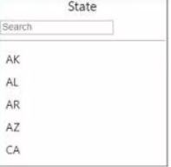**1 slicer**

A slicer is a data visualization tool that filters and segments data. It allows you to filter by specified dimensions. Slicers are visualizations on a Power BI that allow users to readily refine the data.

**2nd GAUGE**

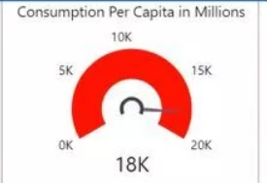A gauge chart is used to demonstrate progress towards a certain goal. It displays the maximum, value with relation to the desired value.it also described that how many people per capita are using there products

**3RD GAUGE**

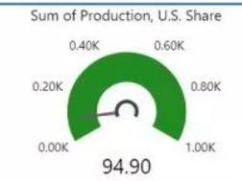A gauge chart is used to demonstrate progress towards a certain goal. It displays the minimum, value with relation to the desired value. It also describe the sum of production share of US

**4TH GAUGE**

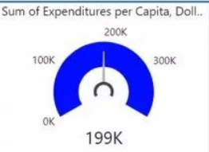A gauge chart is used to demonstrate progress towards a certain goal. It displays current value with relation to the desired value. Explains about the funds spent by the company.

**5th tree map**

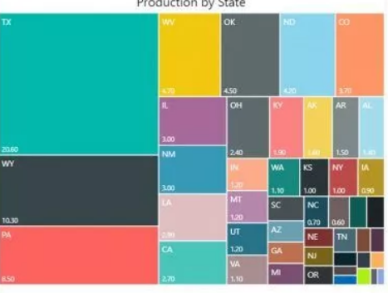Tree maps represent hierarchical data as a collection of nested rectangles it also describe about the production of the products by each state. Each level of the hierarchy is represented by a colored rectangle (branch) with smaller rectangles (leaves) within it.

**6th FILLED MAP**

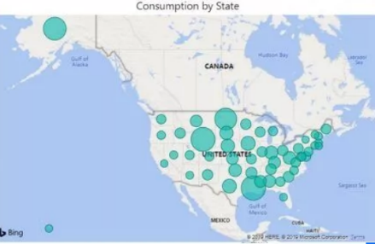A filled map is one that displays data points as Geo-spatial areas rather than points on a map. A continent, country, region, state, city, or county. This displays consumption of the products by each states

**2nd DASHBORD**

**1 STACK COLUMN CHART**

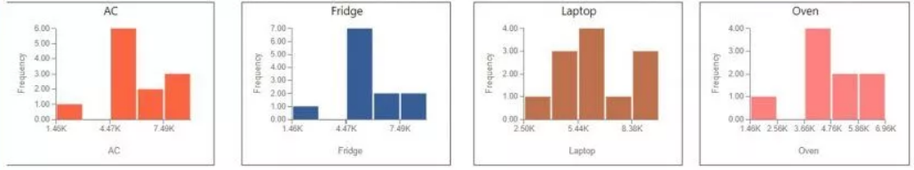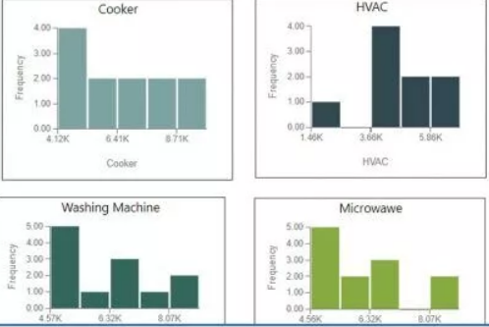charts that combines the Line chart and Column chart together in one visual. these charts describe the relationship between frequency and price of the different products like AC,FRIDGE,OVEN etc

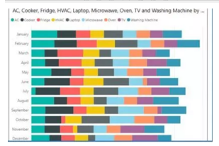

**2Stacked bar chart**

The stacked bar chart compares multiple dimensions to a single measure. The data value will be represented on the Y-axis in the Stacked bar chart, and the axis will represent the X-axis value.

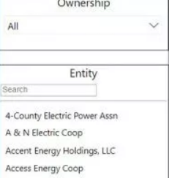**3rd dishoard**

**1 slicer**

A slicer is a data visualization tool that filters and segments data. It allows you to filter by specified dimensions. Slicers are visualizations on a Power BI that allow users to readily refine the data.

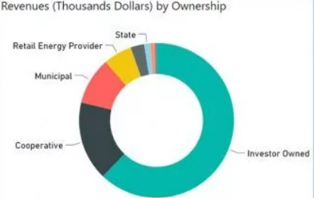**2 donut chart**

A doughnut chart, like a pie chart, depicts the relationship of parts to a whole. The main difference is that the centre is empty, allowing for a label or icon. describe the revnuve of different categories

**3 stacked area chart**

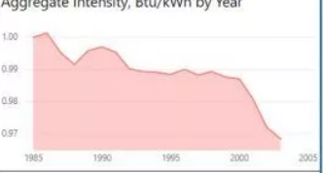Stacked Areas are used to depict a trend in data over time intervals. The difference is that Stacked Areas are used to show how various amounts combine to produce a whole, since it shows how each portion or category contributes to the total quantity.